**TRANBY COLLEGE**

**Psychology (ATAR) – Unit 1**

**Task 8 | Others–Communication and Relationships Test [2015]**

**Question/Answer Booklet**

Student Name

Group: ☐ Friday Session1 ☐ Friday Session 2 ☐ Offline

*Please tick your group.*

## TIME ALLOWED FOR THIS PAPER

Working time for paper: 70 minutes

## MATERIAL REQUIRED/RECOMMENDED FOR THIS PAPER

***TO BE PROVIDED BY THE SUPERVISOR***

This Question/Answer Booklet

***TO BE PROVIDED BY THE CANDIDATE***

*Standard Items:* Pens, pencils, eraser and ruler.

*Special Items:* Calculators satisfying the conditions set by the Schools Curriculum and Standards Authority (SCSA)–*no graphics calculators permitted.*

## *INSTRUCTIONS TO CANDIDATES*

**No other items may be taken into the assessment.**

**It is your responsibility to ensure that you do not have any unauthorised notes or other items of a non-personal nature in the examination room. If you have any unauthorised material with you hand it to the supervisor BEFORE reading any further.**

**Structure of this paper**

|  |  |  |  |  |
| --- | --- | --- | --- | --- |
| **Section** | **Number of questions available** | **Number of questions to be answered** | **Suggested working time (minutes)** | **Marks available** |
| Section One:  Research methods | 1 | 1 | 10 | 6 |
| Section Two:  Short answer | 4 | 4 | 30 | 25 |
| Section Three:  Extended answer | 1 | 1 | 20 | 15 |
|  |  |  | **Marks** | 46 |

**Instructions to candidates**

1. The rules for the conduct of this and the Western Australian external examinations are detailed in the *Year 12 Information Handbook 2014* and *Tranby College’s Assessment Policy.* Sitting this test implies that you agree to abide by these rules.
2. You must be careful to confine your responses to the specific questions asked and to follow any instructions that are specific to a particular question.
3. Spare pages are included at the end of this booklet. They can be used for planning your responses and/or as additional space if required to continue an answer.
   1. Planning: If you use the spare pages for planning, indicate this clearly at the top of the page.
   2. Continuing an answer: If you need to use the space to continue an answer, indicate in the original answer space where the answer is continued, i.e. give the page number. Fill in the number of the question(s) that you are continuing to answer at the top of the page

**Section One: Research Methods (6 marks)**

This section has one (1) question. Write your answers in the spaces provided. Spare pages are included at the end of this booklet. They can be used for planning your responses and/or as additional space if required to continue an answer.

* Planning: If you use the spare pages for planning, indicate this clearly at the top of the page.
* Continuing an answer: If you need to use the space to continue an answer, indicate in the original answer space where the answer is continued, i.e. give the page number. Fill in the number of the question that you are continuing to answer at the top of the page.

**Question One (6 marks)**

A psychologist was interested in the relationship between how strongly a person identifies with a particular ethnic group (ethnic identity) and their connectedness to a group. The psychologist collected questionnaire measures of ethnic identity and connectedness from 300 volunteer adults.

1. State an hypothesis that the psychologist could develop for this study.

**Those with a strong ethnic identity have a higher level of connectedness. (1)**

**Or other good example; linking one factor to another (correlational study)**.

(1)

The results of the study are shown in the scattergram below.

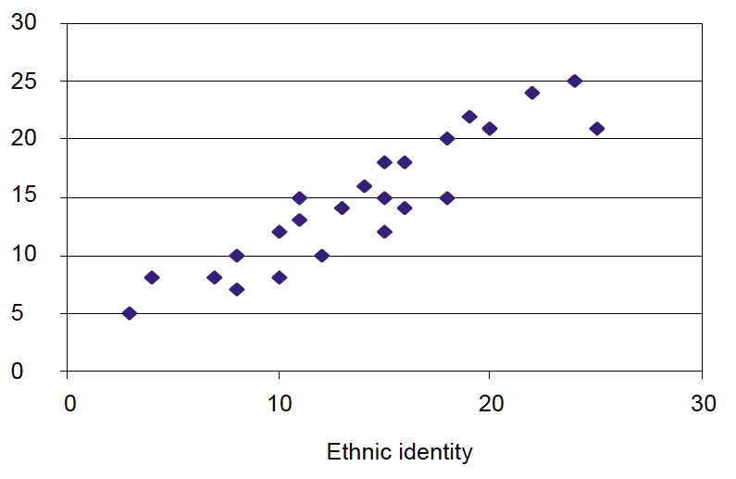

Connectedness

Figure 1

*The relationship between the level of self-reported ethnic identity and connectedness to a group*

* 1. Identify the nature of the relationship between the two variables shown in the scattergram.

**Positive correlation (1)**

(1)

* 1. Do the results shown in the scattergram support the hypothesis stated in Question 1(a)?

**Yes or no (Depends on constructed hypothesis) (1)**

(1)

* 1. Describe a limitation of the research design used in this study that affects the conclusions that can be drawn from the results.

**It is correlational so cannot infer causality (1)**

**Cross-sectional not longitudinal – cannot see what happens over time.**

**Not sure about the sampling – is it a representative population?**

(1)

* 1. Describe an alternative research design that the researchers could use to overcome the limitation identified in Question 1(c)(i).

**Response to 1 (c) (ii) must be logically related to the candidate’s response to Question 1 (c) (i).**

**For two marks, the candidate must indicate the alternative design AND how this would overcome the limitation.**

(2)

**End of Section One**

**Section Two (25 marks)**

This section has four (4) questions. Answer all questions. Write your answers in the spaces provided. Spare pages are included at the end of this booklet. They can be used for planning your responses and/or as additional space if required to continue an answer.

* Planning: If you use the spare pages for planning, indicate this clearly at the top of the page.
* Continuing an answer: If you need to use the space to continue an answer, indicate in the original answer space where the answer is continued, i.e. give the page number. Fill in the number of the question that you are continuing to answer at the top of the page.

**Question Two (4 marks)**

1. Name two (2) examples of pro-social behaviour.

**Altruism**

**Charity**

**Helping those in need**

**Rescue**

**Sacrifice**

**Sharing**

**Sympathy**

(2)

1. Explain why bullying is considered a form of anti-social behaviour whilst a car accident is not.

**Antisocial behaviours are *intentional, voluntary and cause harm* (1)**

**Whilst an accident may cause harm, it might not be intentional or voluntary therefore it is not antisocial (1)**

(2)

**Question Three**  **(6 marks)**

1. Describe three ways in which autism affects communication skills.

**Any three of:**

* **Late onset of language,**
* **struggles to understand anything but the literal meanings,**
* **cannot understand non-verbal communication,**
* **inability to interpret emotional language or sarcasm**
* **Or other relevant point (1 mark each).**

**(Must link how behaviour affects communication – listing symptoms of autism is not correct)**

(3)

1. List three ways in which we can assist people with autism to communicate more effectively.

|  |
| --- |
| **Any three of:**   * **early intervention** * **intensive communications training** * **severe cases learn to sign to communicate** * **understanding their difficulties can help us to assist them** * **any other logical and correct answer. (1 mark each)** |

(3)

**Question Three (8 marks)**

1. Name two types of adolescent peer groups that have been observed by researchers.

**Any two of the answers below may be used. One mark for each.**

* **Cliques**
* **Dyads**
* **Crowds**

(2)

1. Namita is 13 years old and is starting at a coeducational high school. Describe, using the first three of Dunphy’s stages of the changing structure of social groups during adolescence, how Namita’s peer relationships are likely to change throughout high school.

**1 mark for correct name of each stage (exact term as below must be used).**

**1 mark for each correct description.**

* **Stage 1: Cliques (1 mark)**
  + **Namita is likely to make friends with a group of girls (single sex group) (1 mark)**
* **Stage 2: Crowd (1 mark)**
  + **Different cliques will start to interact with each other to form a crowd that has members of both genders (1 mark)**
* **Stage 3: Dyads/Couples (1 mark)**
  + **Clique members of different genders may pair up in dyads / may start dating (1 mark)**

(6)

**Question Four (7 marks)**

1. Name and provide an example of each of the three determinants of liking.

|  |  |
| --- | --- |
| **Determinant of Liking** | **Example** |
| **Proximity (1)** | **Physical closeness such as living close by, attending the same school, or working together so that there are regular or frequent meetings. (1)** |
| **Similarity (1)** | **Mutual attraction, attitudes, values are common.**  **Liking the same movies, food, music, clothes, *or any other correct and logical response.* (1)** |
| **Reciprocity (1)** | **Knowing or thinking someone likes us is enough to make us attracted to them, for example, inviting us**  **to their party, or being paid a compliment, or *any***  ***other correct and logical response*. (1)** |

(6)

1. Using one of the determinants of liking, explain how a friendship can break down.

**Examples of a correct response include:**

**Proximity – moving far enough away/leaving school/changing workplace so that they can no longer meet regularly.**

**Similarity – changing attitudes, values or whatever the mutual attraction was so they are no longer similar**

**Reciprocity – not acting in a likeable manner so we are no longer attracted to them, talking behind their back, name-calling, bullying**

***Any logical and correct answer***

(1)

**End of Section Two**

**Section Three: Extended Answer (15 marks)**

This section contains one (1) question. Pages are included at the end of the questions for planning and writing your answers.

* Planning: If you use a page for planning, indicate this clearly at the top of the page.
* Answering the question: In the pages provided indicate clearly the number of the question you are answering.
* You should refer to relevant psychological concepts, theories and research in your answer.

**Communication** is an important factor influencing an individual’s ability to develop and maintain relationships.

Describe how non-verbal and effective communication skills are used in social interactions with people, and outline the role of language and social skills in maintaining and regulating positive interactions with others.

Your answer should include:

* Definitions of necessary psychological concepts;
* Examples of relevant social skills and non-verbal and effective communication techniques;
* Reference(s) to any relevant research.

|  |  |
| --- | --- |
| **Definitions** | **3** |
| Correct definitions are given, with detailed references to relevant psychological concepts, theories and research that describes and explicitly explains what the theory or research contributes to the topic being discussed. | 3 |
| Correct definitions are given, with minimal (one or two), brief and/or inaccurate descriptions of relevant psychological concepts, theories and research. | 2 |
| Contains some generalisations and statements consistent with current psychological understandings or definitions are a series of personal opinions. | 1 |
| No Definitions | 0 |
| **Social Skills–Robinson (2003)** | **4** |
| An extended answer with detailed references to **Robinsons’ 3 factors (handshakes, forms of address, politeness theory)** explicitly explains how these three skills contributes to enhancing communication. | 3 – 4 |
| An extended answer with minimal brief and/or inaccurate descriptions of **Robinsons’ 3 factors (handshakes, forms of address, politeness theory)** | 2 |
| Contains some generalisations and statements consistent with current psychological understandings or answer is a series of personal opinions or produces a short answer with or without making reference to **Robinson’s (2003) work**. | 1 |
| No answer | 0 |
| **Effective Communication Techniques** | **3** |
| An extended answer with detailed references to **listener/receiver attributes; active listening; working collaboratively** and explicitly explains what the theory or research contributes to effective communication. . | 3 |
| An extended answer with minimal (one or two), brief and/or inaccurate descriptions of **listener/receiver attributes; active listening; working collaboratively**. | 2 |
| Contains some generalisations and statements consistent with current psychological understandings or answer is a series of personal opinions or produces a short answer with or without making reference to empirical evidence. | 1 |
| No answer | 0 |
| **Non-Verbal** | **3** |
| An extended answer with detailed references to **at least 3 non-verbal techniques** and explicitly explains what the theory or research contributes to effective communication. . | 3 |
| An extended answer with minimal (one or two), brief and/or inaccurate descriptions of **non-verbal techniques**. | 2 |
| Contains some generalisations and statements consistent with current psychological understandings or answer is a series of personal opinions or produces a short answer with or without making reference to empirical evidence. | 1 |
| No answer | 0 |

|  |  |
| --- | --- |
| **Structure** | **2** |
| A sophisticated, well-written and well-constructed extended answer, using appropriate language of psychology. Sound use of the conventions except where expression is enhanced by defying conventions. | 2 |
| Literacy enables the construction of an extended answer with well-developed sentences and paragraphs. | 1 |
| Is unable to express ideas with clarity of meaning or answer cannot be understood by the marker. | 0 |
| **Total** | **15** |

**This Page Is Intentionally Left Blank**